(SCHOOL NAME) PRIMARY SCHOOL
School
LOGO

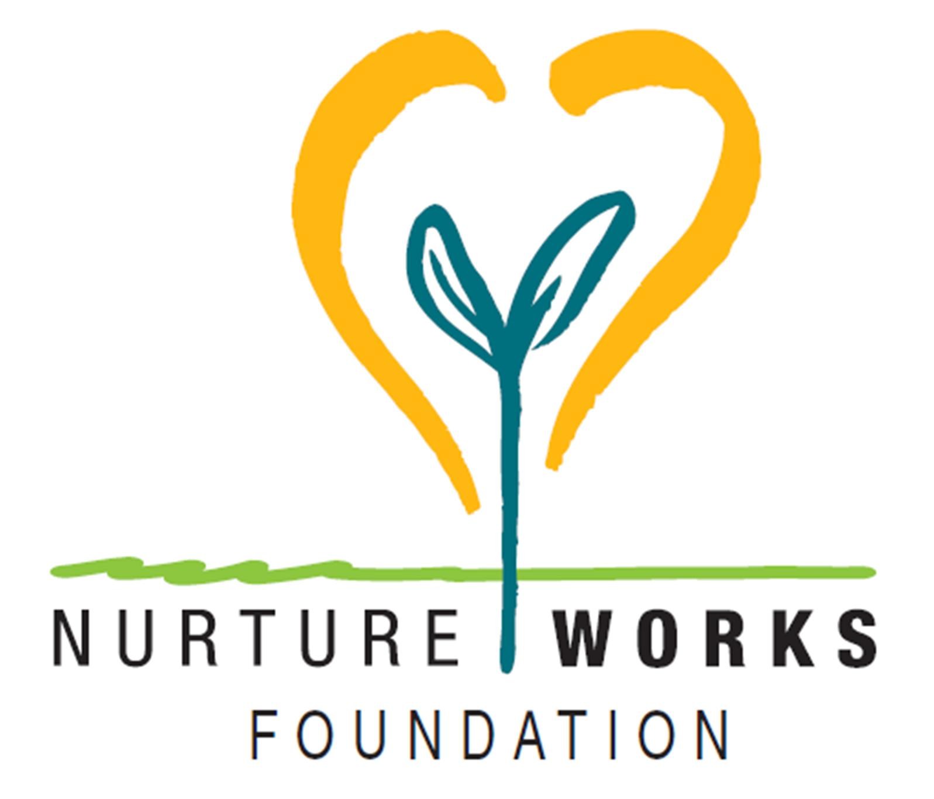

Overcoming the Storms in Life

Dear Parents,
Students in the ( ) class(es) in room(s) ( ) at our school are about to embark upon a program to help them develop skills to overcome grief, loss and change in their lives..
The program is called “BUZ Hope” and is presented by ( ) (Chaplain or teacher) and is one of the innovative BUZ programs.

- The BUZ Hope program has been created to help children build the life skills to handle difficult times in their life. These times include grief, loss and change.
- In the BUZ Hope program we call these difficult times ‘storms’. Everyone has storms in their life and by the time a child has reached the age of nine they would have experienced at least one event of grief, loss or change. This could be the loss of a pet, the death of a grandparent, moving house or school or other difficult event in their life.
- The BUZ Hope program is a proactive program that works with a group of children who share something of their grief experiences but focuses more on their abilities and strengths that helped them to overcome the grief or loss. In BUZ Hope we call this ‘Overcoming the Storms of Life’ or in other words, ‘looking for the rainbow after a storm’.
- Each child receives a BUZ Hope Journal for the program and learns useful journaling skills. They are encouraged to keep their journal and continue using it for any future storms in their life.
- The program will run for 6 x 1 hour sessions commencing on (Day, date and time)

All necessary care and concern will be taken during the running of this program. Should a child show any signs of unexpected or excessive duress during the program the child will be referred to appropriate support services in the school.

Please feel free to contact the school if you would like to discuss this program further.

(Teacher’s Name) (Chaplain’s Name) (Principal’s Name)
Room ( ) Teacher Chaplain School Principal



